Applicant Registration for Nina Mason Pulliam Charitable Trust’s
New Online Grants Management System

All users access the system through the Logon Page.

Applicants accessing the new system for the first time by clicking on the “Create New Account” button.
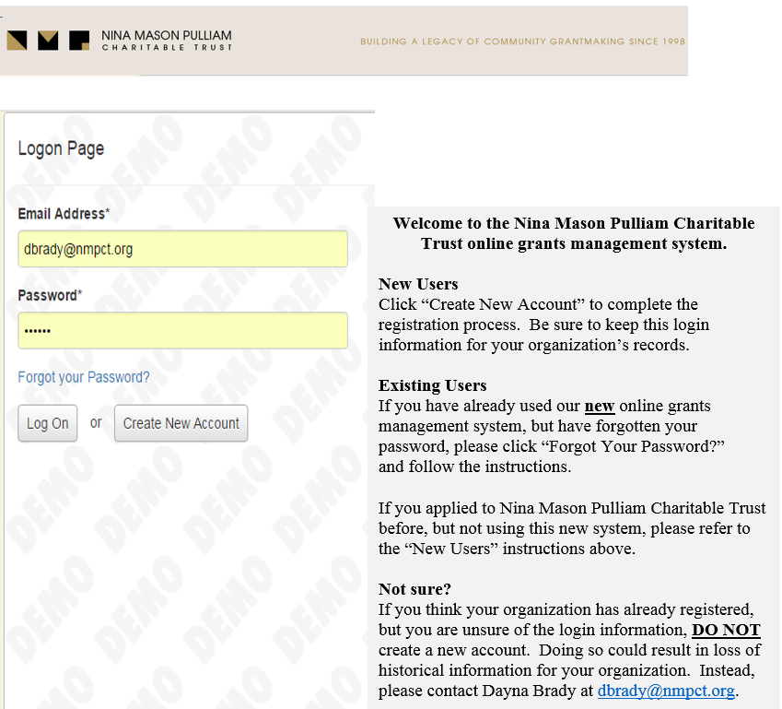
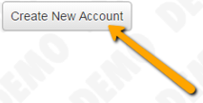

Applicants that have already completed the registration process in the new system, can enter their existing username and password and click Log On to return to their Application Status Page.
- If an Applicant has forgotten their password they can click on the “Forgot Your Password” link.
- They will be asked to enter their email address and will be emailed a reset link.
- If contacted by an applicant, Administrators may also change an applicant's password by editing the applicant's profile and clicking on “Change Password.”
  - Note: Administrators do not have the ability to see other user’s passwords, so a new password must be entered when changing a password.
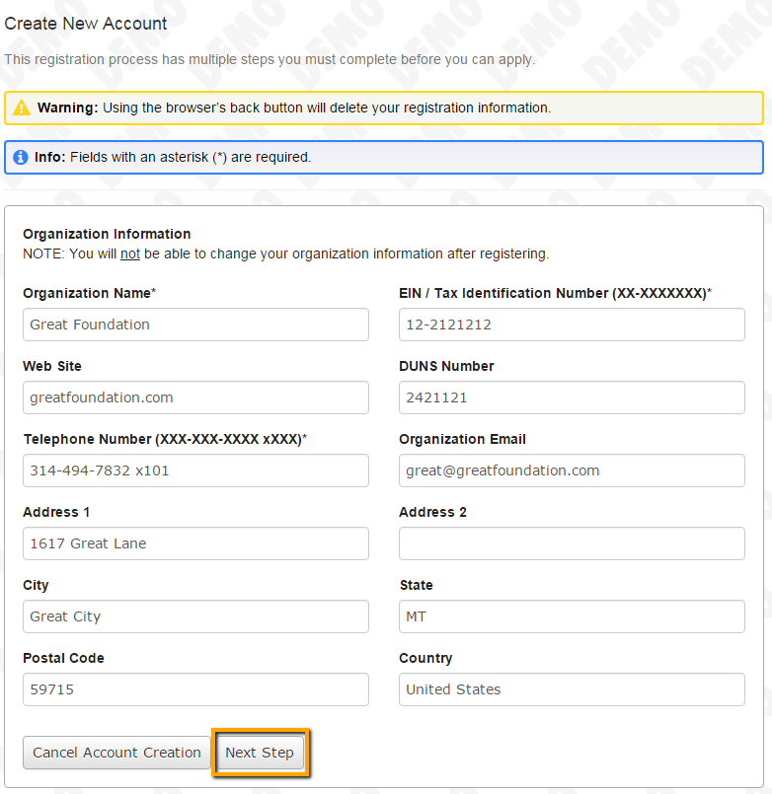
- Creating an account is a multi-step process, with the first page collecting Organization Information; the second page collecting Applicant Information; and pages three and four collecting Executive Officer information.
- Fields in the registration pages that are followed by an Asterisk are required. The applicant cannot go on to the next step in the registration process without completing each required field.
  - If the applicant attempts to go on to the next page of registration without completing a required field, or if they have information entered in a field with incorrect formatting an Error message will appear.
    - Errors must be resolved before moving forward.

- After the Organization Information is entered click on the “Next Step” button.
- The next step is the “Your Information” page, meant to capture the Applicant’s information or the information of the person completing the registration process.
  - If the applicant’s mailing address is the same as the Organization's, the “Copy Address from Organization” button can be utilized to automatically pull the address information from the organization page address fields in the address fields on this page.
  - It is very important to note that the email address entered in the email/login field becomes the Applicant’s Username/Login.
    - For this reason an email address may only be registered into the system once, as the email address is the applicant’s unique identifier.
    - If the applicant tries to re-register, or someone else attempts to register with an email address that is already registered in the system an error message will appear and the email address will have to be changed before registration can be completed.
- Once the fields are completed, click on the “Next Step” button.
  - To navigate to previous pages in registration, the applicant must use the “Previous Step” button at the bottom of the pages for their information entered in registration fields to remain intact. If the applicant attempts to go back to the previous page by using their browser's “back” button they will lose all of their registration information up to that point.
- On the next page the applicant indicates if they are the Organization’s Executive Officer
  - If they select “Yes,” they are taken to a page of optional fields that includes only the fields that were not answered on the “Your Information” page and then to the password creation page. Those fields, if completed, will be appended to the information already entered on the “Your Information” page. In this case you will only be capturing one contact for this organization.
  - If they select “No,” they must provide executive officer information.
- Select “Yes” or “No”.
  - Please note that by entering the executive officer’s email address you ARE NOT creating a login for them, but the executive officer will be listed as a contact on the Organization Summary page.
- Once the executive officer’s information is entered, clicking on the Next Step button will take the Applicant to the password creation page.
  - Password requirements are listed at the top of the page, so the applicant can create their password accordingly.
- Once the password is created, the applicant clicks the “Finish” button.
- Upon clicking Finish an automatic email is sent to the Applicant’s email address that was entered in the Your Information email/login field.
  - This email simply contains their Username.
- Upon clicking finish, the applicant also lands on the Confirmation Page where they are asked to confirm that they received the automatic confirmation email.

Once the applicant clicks “Continue,” the applicant will be logged into the system for the first time, and will automatically land on the “Application Page.”

When an applicant is approved to submit a Letter of Intent or Application, they will be given an access code.

Applicants must enter the access code provided by the Trust into the “Access Code” field in the upper right hand corner of the page and click the “Enter Code” button.
- Please note that access codes are case sensitive.

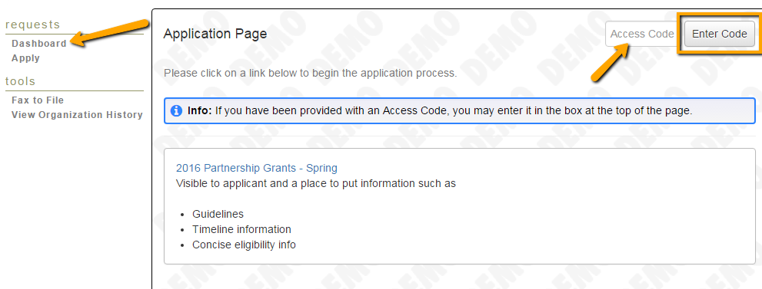
After the initial log on, when returning to the system applicants will land on their “Dashboard” or “Application Status Page.”
On this page, they can:
- View and edit their individual contact information.
- View their Organization information.
- Sign out of the system via the drop-down menu below their name in the top right corner.
- View their own current and past grant requests, including those in draft.
- View submitted requests, follow-ups and documents.
- Edit/submit requests and follow-ups in draft.
- View Organization History, which allows applicants to view requests submitted by other individuals within the same organization.
